# I. Introduction & Guides

## 1. What is WBS?

The WBS (Work Breakdown Structure) is a hierarchical decomposition of the total scope of work to be carried out by the project team to accomplish the project objectives and create the required deliverables. The WBS organizes and defines the total scope of the project and represents the work specified in the current approved project scope statement.

The planned work is contained within the lowest level of WBS components, which are called work packages. A work package can be used to group the activities where work is scheduled and estimated, monitored, and controlled. In the context of the WBS, work refers to work products or deliverables that are the result of activity and not to the activity itself

## 2. WBS Creation with Decomposition

Decomposition is a technique used for dividing and subdividing the project scope and project deliverables into smaller, more manageable parts. The work package is the work defined at the lowest level of the WBS for which cost and duration can be estimated and managed. The level of decomposition is often guided by the degree of control needed to effectively manage the project. The level of detail for work packages will vary with the size and complexity of the project.

Decomposition of the total project work into work packages generally involves the following activities:

* Identifying and analyzing the deliverables and related work,
* Structuring and organizing the WBS,
* Decomposing the upper WBS levels into lower-level detailed components,
* Developing and assigning identification codes to the WBS components, and
* Verifying that the degree of decomposition of the deliverables is appropriate.

A portion of a WBS with some branches of the WBS decomposed down through the work package level is shown below

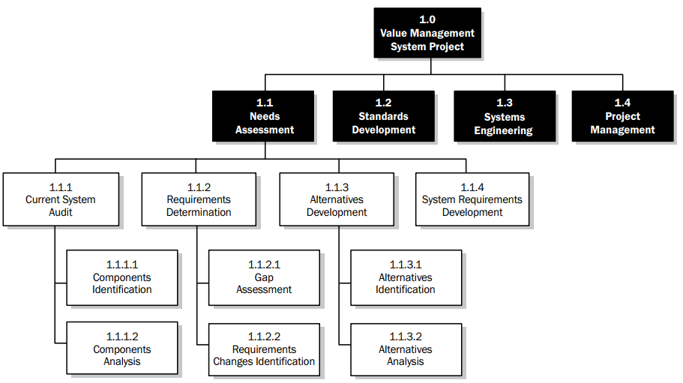

A WBS structure may be created through various approaches. Some of the popular methods include the top-down approach, the use of organization-specific guidelines, and the use of WBS templates. A bottom-up approach can be used to group subcomponents. The WBS structure can be represented in a number of forms, such as:

* Using phases of the project life cycle as the second level of decomposition, with the product and project deliverables inserted at the third level

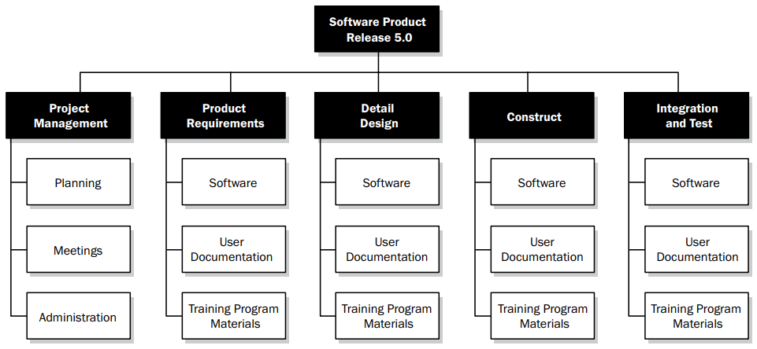

* Using major deliverables as the second level of decomposition, as shown below  
  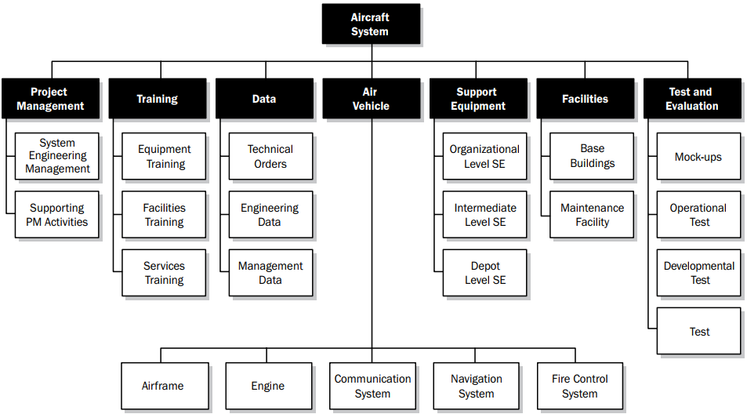
* Incorporating subcomponents that may be developed by organizations outside the project team, such as contracted work. The seller then develops the supporting contract WBS as part of the contracted work.

Decomposition of the upper-level WBS components requires subdividing the work for each of the deliverables or subcomponents into its most fundamental components, where the WBS components represent verifiable products, services, or results. If an agile approach is used, epics can be decomposed into user stories. The WBS may be structured as an outline, an organizational chart, or other method that identifies a hierarchical breakdown. Verifying the correctness of the decomposition requires determining that the lower-level WBS components are those that are necessary and sufficient for completion of the corresponding higher-level deliverables. Different deliverables can have different levels of decomposition.  
To arrive at a work package, the work for some deliverables needs to be decomposed only to the next level, while others need additional levels of decomposition. As the work is decomposed to greater levels of detail, the ability to plan, manage, and control the work is enhanced. However, excessive decomposition can lead to nonproductive management effort, inefficient use of resources, decreased efficiency in performing the work, and difficulty aggregating data over different levels of the WBS.

Decomposition may not be possible for a deliverable or subcomponent that will be accomplished far into the future. The project management team usually waits until the deliverable or subcomponent is agreed on, so the details of the WBS can be developed. This technique is sometimes referred to as rolling wave planning.

The WBS represents all product and project work, including the project management work. The total of the work at the lowest levels should roll up to the higher levels so that nothing is left out and no extra work is performed. This is sometimes called the 100 percent rule.

## 3. WBS Dictionary

The WBS dictionary is a document that provides detailed deliverable, activity, and scheduling  
information about each component in the WBS. The WBS dictionary is a document that supports the WBS. Most of the information included in the WBS dictionary is created by other processes and added to this document at a later stage. Information in the WBS dictionary may include but is not limited to:

* Code of account identifier,
* Description of work,
* Assumptions and constraints,
* Responsible organization,
* Schedule milestones,
* Associated schedule activities,
* Resources required,
* Cost estimates,
* Quality requirements,
* Acceptance criteria,
* Technical references, and
* Agreement information

# II. Templates

## 1. WBS Template

The project WBS can be presented in text, Ms Word, Ms Excel or any other relevant tools with WBS structure items, noted right after numeric system. It’s content is something like below

1. Main category 1

1.1 Subcategory

1.2 Subcategory

1.2.1 Sub-subcategory

1.2.2 Sub-subcategory

1.3 Subcategory

1.4 Subcategory

1. Main category 2

2.1 Subcategory

2.2 Subcategory

2.2.1 Sub-subcategory

2.2.2 Sub-subcategory

2.3 Subcategory

2.4 Subcategory

1. Main category 3
   1. Subcategory
   2. Subcategory

3.2.1 Sub-subcategory

3.2.2 Sub-subcategory

* 1. Subcategory
  2. Subcategory

1. Main category 4
   1. Subcategory
   2. Subcategory
      1. Sub-subcategory
      2. Sub-subcategory
   3. Subcategory
   4. Subcategory

## 2. WBS Dictionary Template

A WBS dictionary may look similar to the example shown in figure below

